**In-class Exercise**

1- (50 points) Write a procedure that insert paid invoices from **paid_invoices table** into the **invoice_archive** **table**. Only those paid invoices that are older than or equal to 31-05-2014 should be transferred. Those transferred invoices should be **deleted** from paid_invoices table.

Execute the procedure and:

Submit the code of the procedure

“create or replace procedure archive_invoices

as

cursor transfer_cursor is

select * from paid_invoices where

invoice_date <= to_date('31-05-2014','dd-mm-yyyy');

transfer_row transfer_cursor%rowtype;

begin

for transfer_row in transfer_cursor loop

insert into invoice_archive values (transfer_row.INVOICE_ID,

transfer_row.VENDOR_ID, transfer_row.INVOICE_NUMBER, transfer_row.INVOICE_DATE,

transfer_row.INVOICE_TOTAL, transfer_row.PAYMENT_TOTAL, transfer_row.CREDIT_TOTAL,

transfer_row.TERMS_ID, transfer_row.INVOICE_DUE_DATE, transfer_row.PAYMENT_DATE);

delete from paid_invoices where (transfer_row.Invoice_id = paid_invoices.Invoice_id);

end loop;

end;”

“execute archive_invoices;”

Submit the result of the following queries:

Select count(*) from invoice_archive;



Select * from invoice_archive where rownum<15;

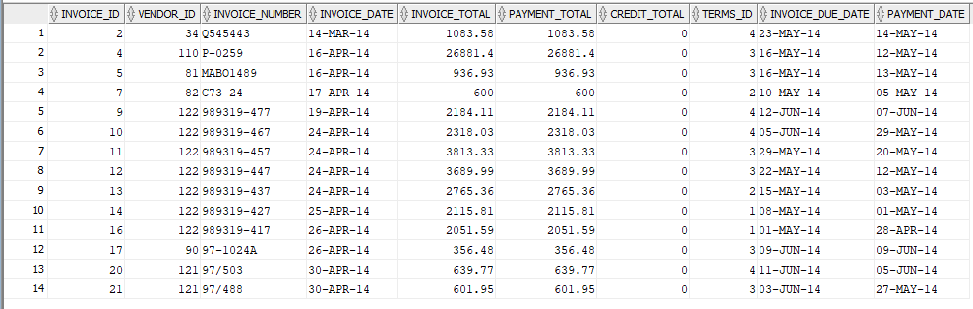

2- (50 points) Create a trigger named invoice_update that is fired before the UPDATE operation of invoice_total column of invoices table. The trigger simply displays the vendor ID , old invoice_total and new invoice_total whenever the invoice_total is updated.

Submit the code of the trigger and the screenshot for two test cases results:

“SET SERVEROUTPUT ON;

CREATE OR REPLACE TRIGGER invoice_update BEFORE

UPDATE OF invoice_total ON invoices

FOR EACH ROW

BEGIN

dbms_output.put_line('Vendor ID: ' || :old.vendor_id);

dbms_output.put_line('Old Invoice Total: ' || :old.invoice_total);

dbms_output.put_line('New Invoice Total: ' || :new.invoice_total);

END;”

“set serveroutput on;

update invoices set invoice_total = 700 where invoice_id = 6;

Select * from invoices where invoice_id = 6;”

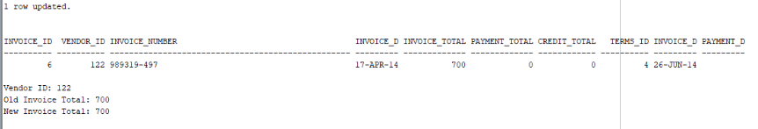

“set serveroutput on;

Update invoices set invoice_total = 3211 where invoice_id = 18;

Select * from invoices where invoice_id = 18;”

